 | NON-CONFORMITY REPORT FOR ASSESSMENT VISIT | F-02/06  Issue Date: 11/11/19  Rev No: 06

ACTIVITY: | \Assessment Surveillance  Re-Assessment Scope extension  Other Please specify: |  | NCR No: | 1
ACTIVITY: |  |  | Accr./Appl.No:
ACTIVITY: |  |  | Non-conformity category:  Very serious  Essential
ORGANIZATION: | Quality control Lab vital Agri. Nutrients (Pvt) ltd. |  | Time limit for correction:
Department: | Lab |  | 6 weeks
Team Leader. | Mr. Atique Ur Rehman | Mngt. Rep. | Mr. Hammyat Hussain
Assessor | Dr. Muhammad Aftab | Mngt. Rep.
Expert |  | Mngt. Rep.
DESCRIPTION:  The authorization permit of Quality control manager (Mr. Himayat Hussain) Checked the authorization permit needs to revise as per JDs(QCL-JD-02 REV#01 Dated 24-09-24)of the QCM (NC).  Mr.Himayat Hussain Quality control Manager vide authorization permit (QCL-FRM-2.01) as per standard clause 6.2.6 clause (a) and authorization related to the interpretation and implitation of the Decision rule/statement of conformity is missing as per clause 6.2.6(b) (NC)  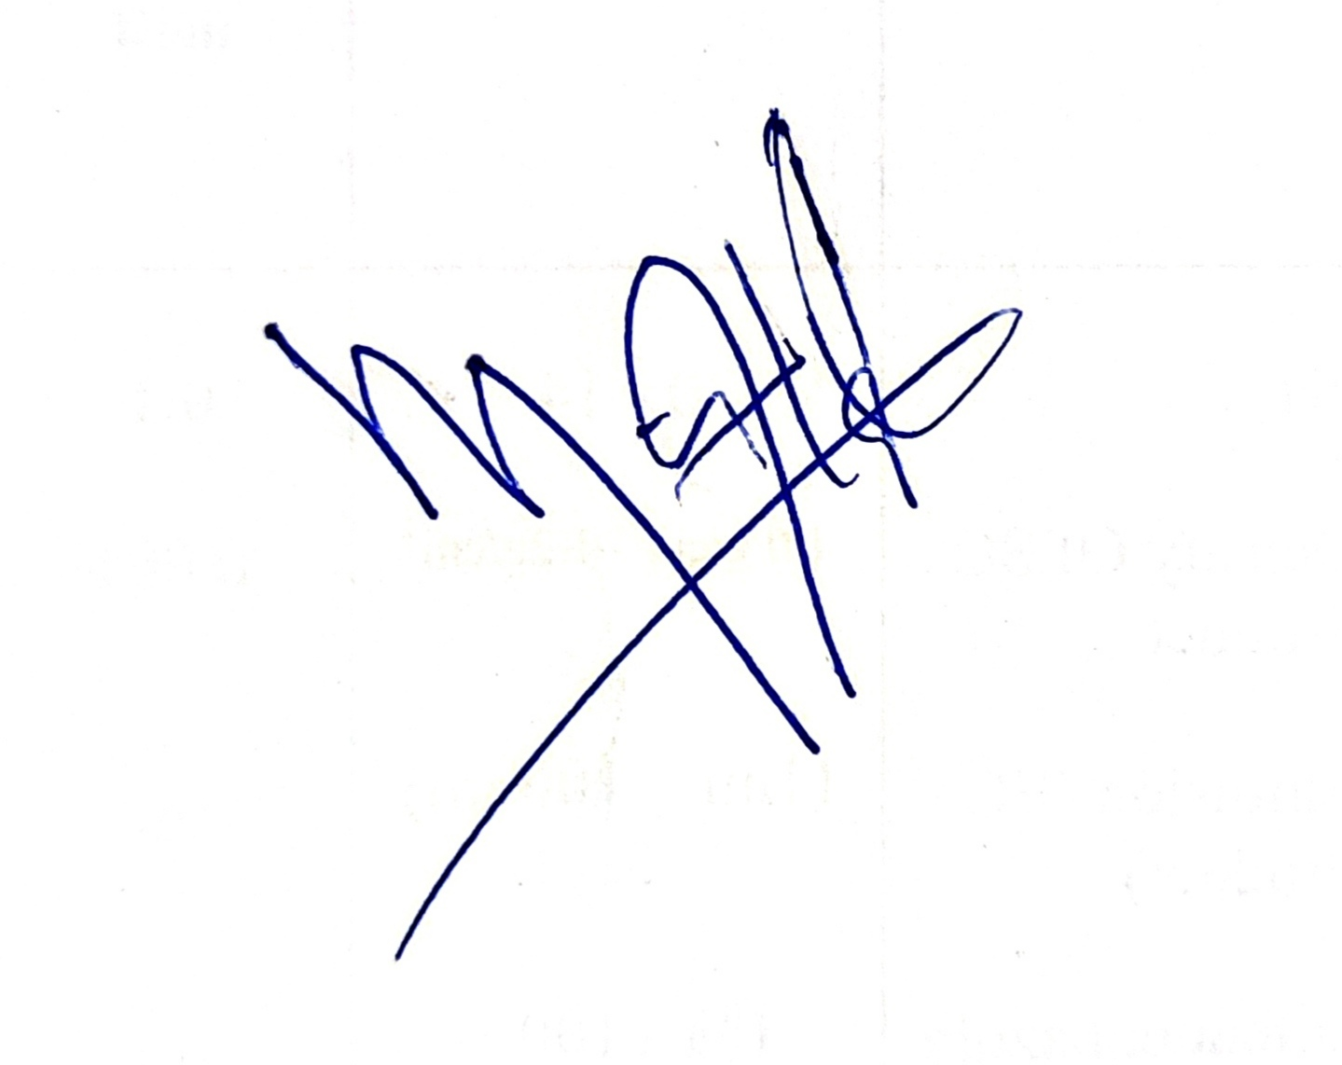  11-07-2026 _______________ ________________________  Date Signature Assessor/Expert Signature (Management Representative) |  |  | Requirement of:  ISO/IEC 17025  ISO 15189  ISO/IEC 17021  ISO/IEC 17020  Others:
 |  |  | Ref. Organization’s doc.
CORRECTIVE ACTIONS: (Note: It is mandatory to attach Root Cause Analysis)  The QCM authorization permit (QCL-FRM-2.01) was revised in accordance with the updated Job Description and ISO/IEC 17025 clause 6.2.6. Authorization for interpretation and implementation of the decision rule/statement of conformity was added, and the revised permit was reviewed and approved.  Action are documented in the amendment no: ___________________  _________________ ________________________________  Date Signature (Management. Representative) |  |  | It is not necessary to attach documentation
REASON FOR CLOSING: (To be filled in by the Team Leader.)

The non-conformity is closed based on satisfactory documentation from the organization
The non-conformity is closed based on recommendation from the technical assessor
Implementation of the corrective actions will be followed up at the next visit
Remarks (if any)---------------------------------------------------------------------------------------------------------------------------------------------------------------------------------------------------------------------------------------------------------------

The non-conformity is closed: _______________ _____________________________
Date Signature (Team Leader.)

